Unit Three
Reading Materials
Passage 1

The Transformative Power of 5G
This once-in-a-decade mobile phone network upgrade is expected to place us squarely in the middle of the Internet of Things.
by Scientific American Custom Media

1 Major carriers are in the process of rolling out ultra-high-speed mobile-phone networks that use fifth-generation (5G) technology, transmitting data up to 50 times faster than current phone networks. But the promise of 5G is that it will provide more than just a boost to our phone service and download speeds. “5G will be one of the more transformative technologies we’ve had so far,” says Karri Kuoppamaki, vice president of radio network technology and strategy at T-Mobile, where he is overseeing the company’s rollout of 5G networks.
2 There are three differences between 5G and the current 4G: speed, bandwidth and what network specialists call latency, which is the time it takes for data to move from a server on the network to a device. 5G networks are faster, can handle a higher volume of data, and reduce wait times. The new technology is able to shoot data from millions of local sensors or gadgets to distant cloud computers for processing and then return the relevant guidance — all in a fraction of a second. This deluge of data flooding through our society will enable a host of new services, including connecting new devices and equipment.
3 Sensors themselves can be tinier, cheaper and more durable because of yet another advantage of 5G: smaller batteries. 5G devices stay connected to the network instead of engaging in the back-and-forth signaling that 4G networks require for connectivity, which saps （reduce） battery life. 5G will power up our daily lives. “We’ll constantly have the information we need to make decisions,” Kuoppamaki predicts.
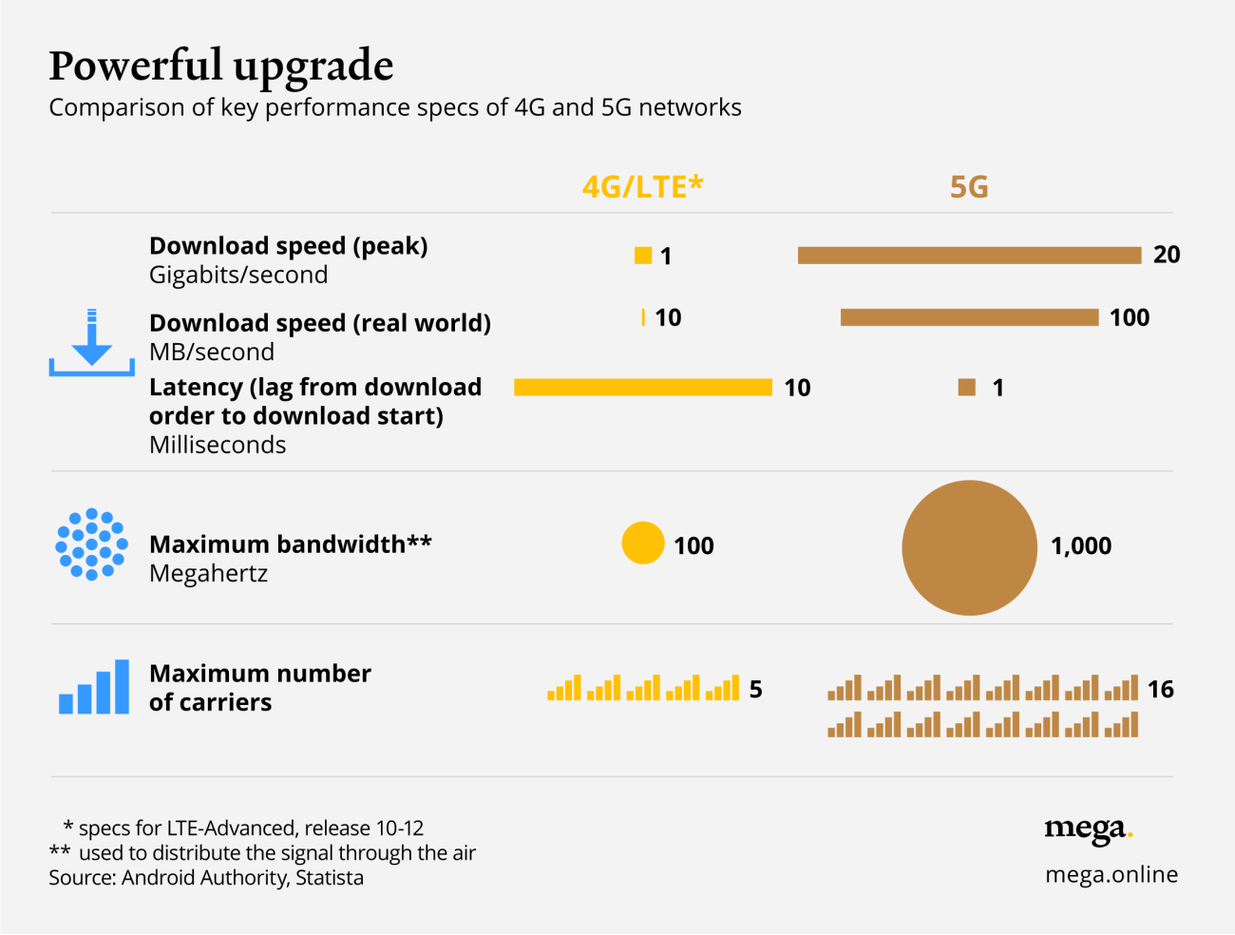
4 The first 5G networks came online in late 2019 in major cities around the world. That’s more or less in keeping with the pattern of major decadal upgrades in phone-network capabilities. To get a sense of how influential these upgrades can be, consider that the last big upgrade — from 3G to 4G networks around 2010 — drove the proliferation of phone apps that are now integral to our connected culture. “The move to 4G created the app economy, and made Google and Facebook what they are today,” says Kuoppamaki.
5 The first applications to benefit from 5G will likely be those involving live-streaming video — that is, using a phone to record and transmit an event as it is happening. 5G speeds can cope with 8K image resolution, which entails quadruple the amount of information of ultra-high-definition 4K images and beyond even the capabilities of most TVs. The network also has enough extra bandwidth to simultaneously transmit multiple other video streams, allowing users to switch between camera angles at sporting events, for example, or to pan the viewpoint around 360 degrees.
6 Other applications certain to get early 5G upgrades include mobile gaming and virtual reality (VR) apps that embed (immerse) goggle-wearing users in 3D images. These applications will benefit from another aspect of 5G networks. “There’s a misconception that 5G is only about higher speeds,” says Kuoppamaki. “Low latency is a big benefit, too, a more comprehensive, end-to-end measure of data speed than transmission speed.” Gaming and VR apps work best when the images change almost instantly in response to user input, whether it’s swiping on the screen, waving a hand or turning a head. The new 5G networks will reduce latency by 80 percent, providing a near immediate response.
7 The speed and fast response of 5G networks will also affect the kit: VR goggles, for example, can be sleeker, lighter and less clunky, notes Kuoppamaki. That’s because today those goggles need to provide much of the processing power that turns raw data into actual images. But 5G networks can zip data back and forth quickly enough to mean that much of the processing can move to the cloud.
8 Closely related to VR is augmented reality (AR), where graphics and text are superimposed on real images. AR, too, will become widespread with 5G, and in many cases essential, says Kuoppamaki. “Imagine you want to try a little home plumbing to change your faucet,” he says. “You could put on your goggles and let an augmented-reality app walk you through each step under the sink, while you look at your pipes.” 5G-charged VR and AR apps could literally add a new dimension to education and training in almost any domain.
9 And, of course, there is the Internet of Things, which will surround us with many ‘smart’ items. Around the home, that could be tomato plants in the garden that can ask for water, roofs that warn of weaknesses after extreme weather, jackets that keep parents updated on a child’s location, trash cans that ask to be emptied, and milk cartons that point out expiration dates. In the streets, it’s a heads-up on open parking spaces, second-to-second data on surrounding traffic for driverless cars, local air-quality warnings, icy sidewalk alerts, and much more.
10 “The Internet of Things will change the way we live and how we interact with the environment around us,” says Kuoppamaki.
11 Businesses will benefit, too. Industrial robots, drones and driverless trucks will be more responsive to obstacles and fast-changing conditions. Cables will be redundant, even for the most complex computer-controlled machines, making them easier to move around. Businesses will be free to reconfigure the factory floor in response to product changes or fluctuations in customer orders. “Today, it’s hard for factories to change quickly,” says Kuoppamaki. “If you can make equipment more mobile, you can reduce the time to market.” What’s more, he adds, sensors in the machinery will constantly feed remote AI software with the monitoring data it needs to self-adjust in response to variations in product quality, and to judge when the equipment requires preventive maintenance to avoid down-time and more expensive repairs.
12 The 5G transformation won’t happen overnight, warns Kuoppamaki. The first wave of sophisticated applications are likely three or more years away. Cost may be a temporary barrier, too because currently, the only phones that can access 5G networks are top-of-the-line new models.
13 But the initial benefits, mostly those relating to speeding up existing applications, are already arriving.
14 “Like all new technologies, adoption starts in the high end, and then makes its way down,” he says. “It will only take a few years before we see 5G everywhere.”

https://www.scientificamerican.com/custom-media/pictet/the-transformative-power-of-5g/

Notes
- Internet of Things (IOT)
A system of interrelated computing devices, mechanical and digital machines, objects, animals or people that are provided with unique identifiers ( UIDs ) and the ability to transfer data over a network without requiring human-to-human or human-to-computer interaction.
- T-Mobile
A multinational mobile phone operator. It is a subsidiary of German Telecom and belongs to the Freemove Union. T-Mobile operate GSM networks in Western Europe and the United States and participate in network operations in Eastern Europe and South-East Asia through financial means. The company has 109 million users and is one of the world's largest mobile phone companies.
- 8K image resolution 8K分辨率
- ultra-high-definition 4K images超高清4K图像
- virtual reality (VR) 虚拟现实
An artificial environment created with computer hardware and software and presented to the user in such a way that it appears and feels like a real environment.
- VR goggles VR眼镜即VR头显，虚拟现实头戴式显示设备
- augmented reality (AR) 增强现实
A type of virtual reality that aims to duplicate the world’s environment in a computer. An augmented reality system generates a composite view for the user that is the combination of the real scene viewed by the user and a virtual scene generated by the computer that augments the scene with additional information.
- down-time停机时间；停工期

Passage 2

Qualcomm makes strides in 5G network development: Here’s what it means for you
By Christian de Looper October 21, 2020

1 Qualcomm wants to make 5G more accessible, more common, and faster. The company recently held its annual 5G Day event, where it made a few announcements related to the rollout of 5G, the continued development of 5G tech, and more.
2 Of course, you might be wondering whether any of this really matters to you and how it will benefit the average smartphone user. Here’s a quick rundown (outline) of Qualcomm’s new 5G-related announcements, and what they could mean for you.

Qualcomm wants to help build 5G infrastructure
3 Traditionally, Qualcomm has developed and manufactured chipsets and modems that can connect to 5G networks, but now it wants to play a bigger role in the actual infrastructure behind 5G. Specifically, the company is building Radio Access Network (RAN) chips, which are designed to be used in 5G base stations for your phone (or tablet, or computer) to connect.
4 It’s important to note that Qualcomm won’t necessarily be directly competing with the likes of Huawei and Ericsson. Instead, it will supply those companies with the 5G chips and related software to power their infrastructure. That marks a shift for cell infrastructure, which has traditionally been built all by one company. Making 5G networks a little more modular also means that they could be more easily updated and developed without carriers having to deploy all-new infrastructure, but it remains to be seen if that will actually happen.
5 But what does that mean for you? Well, Qualcomm has been a leader in the 5G world for some time, and it entering this particular business could help make real-world 5G networks faster and more reliable. Unlike other companies, Qualcomm has expertise in the end-user device chipsets, too, so it knows exactly how to make them interoperate for the best performance. Qualcomm’s chips, of course, support the super-fast mmWave (millimeter-wave) networks, and the widespread Sub-6 networks, so if they become widespread, you may get much better mmWave support.

There’s a new record for fastest 5G speeds
6 Qualcomm also announced that in partnership with Verizon and Ericsson, it achieved a peak 5G speed of a whopping (very large) 5.06Gbps. The speed was achieved with a bunch of fancy tech on a mmWave network and using what’s called carrier aggregation, which combines multiple channels to make for faster speeds.
7 According to Qualcomm, 5G will eventually reach speeds of 10Gbps(gigabytes千兆字节）, but that’s just talk right now — we’ll have to wait and see if that happens and if it’s accessible.
8 It’s important to be very clear about how Qualcomm achieved this huge peak speed — in a tightly controlled lab environment. In other words, carriers aren’t going to be able to flick a switch and turn on 5Gbps speeds anytime soon.
9 But that doesn’t mean that it won’t benefit you. As companies like Qualcomm continue to work on 5G development, and as the tech gets better and better it will eventually make its way to the real world. When it does, you likely won’t get 5Gbps, considering things like distance, obstacles, and the number of people using the same cell tower as you. But you should still get faster speeds than you did before, and hopefully, faster speeds than you’ll get on even the best 4G LTE networks.
https://www.digitaltrends.com/mobile/qualcomm-5g-day-2020-roundup/

Notes
- Qualcomm高通公司
Founded in 1985 and headquartered in San Diego, California, USA, Qualcomm is the world's leading wireless technology innovator and has changed the way the world connects, computes and communicates. Its invention opened the era of mobile interconnection.
- Radio Access Network (RAN) 无线电接入网
A part of a mobile communication system and the realization of radio access technology. It exists on a device, a mobile phone, a computer, or any remotely controlled machine with a core network and provides a communication connection between the two.
- mmWave (millimeter-wave)毫米波
Millimeter wave is an electromagnetic wave between microwave and light wave. Usually millimeter wave band refers to 30 GHz~300 GHz, corresponding wavelength is 1 mmGHz~10 mm.. The millimeter wave communication refers to the communication with millimeter wave as the carrier of information transmission.
- Sub-6
The global 5 G network frequency band is mainly divided into two major ranges: Sub-6GHz and millimeter wave. At present, the main use of this band in China is Sub-6GHz, which has strong signal penetration but slower speed of data transmission than that of millimeter wave.
- Verizon威瑞森电信
The largest local telephone company and the largest wireless communications company in the United States.
- Ericsson爱立信公司
Founded in 1876 in Stockholm, Sweden., Ericsson is the world's largest provider of mobile communications networks.
- carrier aggregation载波聚合
The aggregation of two or more carrier units (Component Carrier) to support a larger transmission bandwidth (up to 100 MHz).
- LTE (Long Term Evolution)长期演进技术
LTE (Long Term Evolution) project is an evolution of 3G, a transition between 3 G and 4 technologies, and a global standard of 3.9 G, which improves and enhances 3G air access technology by using OFDM and MIMO as the sole criteria for its wireless network evolution.

